**RFID BASED PASSPORT DETAILS**

**ABSTRACT**

The main functionality of this project is to access the passport details of a passport holder through RFID technology. For this purpose the authorized person is given an RFID card. This card contains an integrated circuit that is used for storing, processing information through modulating and demodulating of the radio frequency signal that is being transmitted. Thus, the data stored in this card is referred as the passport details of the person.

Passport verification and checking is a very time consuming process. This proposed system simplifies the process by giving the authorized person an RFID tag containing all the passport details like name, passport number and nationality etc. Once, the person places the card in front of the RFID card reader, it reads the data and verifies it with that data present in the system and if it matches then it displays the details of the passport holder. Here we use microcontroller from PIC family. For display a 16X2 LCD is used. The status also can be retrieved from this system by pressing the status button interfaced to a microcontroller.

Further the project can be enhanced by using finger printer module. This overcomes the drawbacks of RFID and provides high level of security in the system.

**BLOCK DIAGRAM**

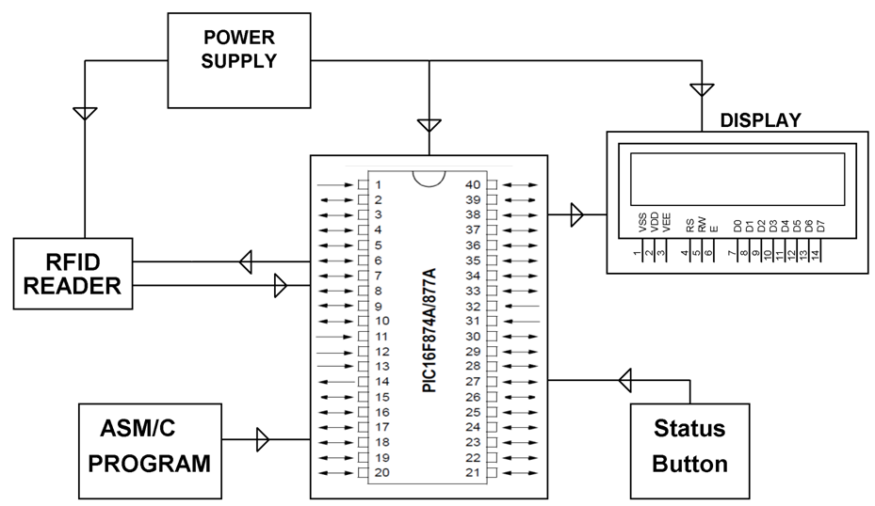

**SOFTWARE REQUIREMENTS:**

HI-TECH PICC Tool suite

Language: Embedded C or Assembly

**HARDWARE REQUIREMENTS:**

PIC series Microcontroller, RFID Reader, RFID tags, LCD, Resistors, Capacitors, Diodes, Transformer, Voltage Regulator, Crystal, and LED.